**DevOps Simplified -**

**The Balbhas Approach**

Executive Summary

This article provides an introduction to DevOps methodology and makes an attempt to justify the need for DevOps in a customer context. ***B-SwiftTM*** framework is a DevOps solution approach, uniquely designed by BalbhasTM for its customers. The salient components of this framework include a maturity assessment, DevOps migration planning and DevOps implementation methodologies. This article highlights certain unique benefits that can incentivise a customer to migrate to DevOps. This article also lists the critical success factors for the successful migration to DevOps.

**Author**

Dr. Arumugam Natesan, Director & Practice Head, heads the Managed Services BU at Balbhas. He comes with a rich experience of 22+ years in various sectors such as Application Maintenance, Production Support, Quality Management, IT Service Management, Managed Service Delivery & Service Support and IT Governance. As a thought leader, Dr. Arumugam has helped various customers transform their IT service delivery to the next levels, by means of advisory and implementation services.

**About Balbhas**

Balbhas is a Leader in Automation & Technology Services to IT customers of Small, Medium and enterprise businesses. Balbhas focuses on areas such as Development Process Automation, Support Process Automation and Performance Engineering, with an objective to accelerate customers business and optimize their IT spend through large scale automation, simplification and optimization strategies.

**1 Background**

As we all know that we are in a fast-moving world, with very less patience to wait to receive the services being given to us. This analogy is largely applicable to IT and its Business, as well. Generally, IT & Business stakeholders are unreasonably paranoid and concerned about:

* *“How can we introduce this service on-time?”*
* *“How can we outnumber our competition for this product?”*
* *“How can we ensure a quick, smooth and stable release?”*
* *“How can we improve our time to market?”*
* *“How can we address the problems before the end users get impacted?”*

This situation is true whether the customer is a naïve or a long-timer in the service industry or whether the customer has a tiny foot print or has a large IT estate.

Thus, it is very logical that the IT in-house staff and the Service Providers are required to rapidly shift from a legacy way to a new way of delivering products and services. While Developers always want to deliver changes as soon as possible, Testers want to ensure product quality using a laborious process and Operations, on the other hand, want reliability and stability of existing stuff in production. This *wall of confusion* not only exists between the mindsets of these teams but also with the tools they use. Development uses some tools and operation uses some other tools to perform the same stuff. A continuous delivery approach is needed, rather than delivering “big” releases, in a silo’ed manner.

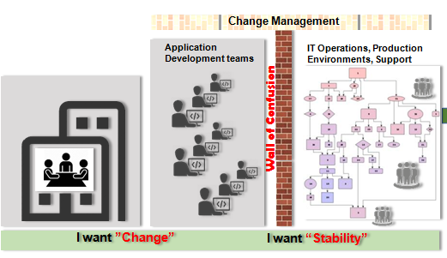

DevOps breaks down these walls of confusion between development and operations teams, by unifying development and operations for better, faster outcomes. It is a radical methodology to accomplish those business concerns aforementioned. Thus, embracing DevOps has become a real, compelling need. Patrick Debois, who is often called “*the father of DevOps*”, coined the word “DevOps” in 2009. As the word depicts, it was formed by combining two words: “development” and “operations”. DevOps is a collaborative way of developing and deploying software. It is a software development method that stresses communication, collaboration and integration between software developers and IT operation professionals.

In this article, BalbhasTM, an automation and technology service provider, is providing its DevOps constructs, based on the industry experience and expectations. It discusses a unique DevOps readiness assessment methodology and the DevOps implementation strategy.

**2. Why DevOps**

It is relevant to know what incentives that DevOps brings to IT. DevOps combines the best contribution of all teams fulfilling the following objectives:

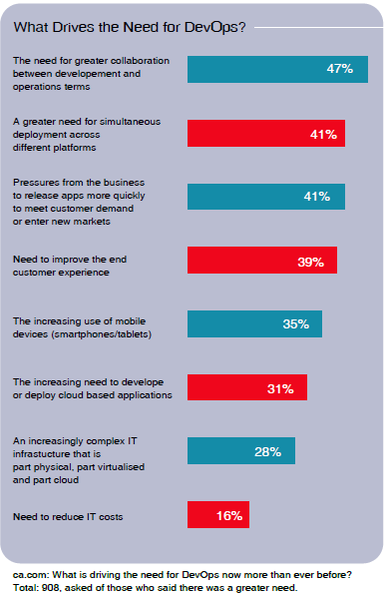

* Develop and verify against production-like systems
* Reduce cost/time to deliver
* Deploy often, deploy faster with repeatable, reliable process
* Increase the product quality
* Reduce the cost/time to test
* Improved ability to ensure proper configuration management
* Reduce Defect cycle time
* Increase the ability to quickly fix the defects
* Increase the utilization of environments
* Reduce the deployment related downtime
* Reformed channels for communication/ feedback
* Minimize the rollbacks or rollback quickly without impacting the business

There is an increased adoption of DevOps (per Gartner & IDC reports). The “Right Scale 2017 State of the Cloud Report” shows that DevOps adoption has increased from 74% to 78%. Gartner says that companies which practice DevOps enjoy:

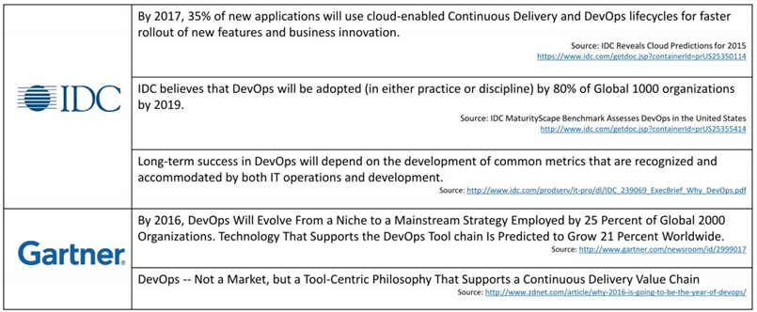

* 200x more frequent deployments
* 2555x faster lead times
* 24x faster recovery
* 3x lower change failure rates

**3. B-SwiftTM – The Balbhas DevOps Solution**

BalbhasTM has a holistic DevOps solution for our customers, in terms of **B-SwiftTM** framework.

This framework has an assessment suite, Business Justification, Migration Planning & Implementation methodologies. The whole framework revolves around *7C-principles and* is aligned to the *standard 7-pillars* (described later) of a typical Development – Operations life cycle. BalbhasTM proposes to include adequate monitoring components and controls to oversee, succeed and sustain the DevOps initiative.

**3.1 DevOps Maturity Assessment**

As the success of any change in the methodology depends on the readiness of the organization to adopt the change, a quick & formal assessment is needed. BalbhasTM DevOps Assessment methodology focuses on the following key areas:

*People*

* + How fast can people adopt to DevOps?
  + What specific roles are to be created and retained?

*Process*

* + What processes need to be streamlined and industrialized?
  + How best are the development, testing and operational processes simplified?
  + What is the current rate of automation in the delivery life cycle?

*Platform*

* + What is the current level of maturity of the existing tools to accept DevOps methodology?
  + What tools are to be retained/ reused?

*IT Systems*

* + How complex is the application architecture now?
  + What is the currency of the underlying infrastructure?
  + What is the current level of utilization of the environments?

By having done the assessment, the current status quo (people challenges, process issues, tool barriers etc.) is fully uncovered holistically. Recommendations are to be evolved based on the gaps, challenges and expectations. Thus, the key outcomes of the assessment are: identification of automation opportunities, process changes/ improvements, identification of new tools, definition of common metrics; they are included in the implementation roadmap. A business case is needed to get the buy-in from the Leadership to budget, plan and to commence the implementation of the recommended changes.

**3.2 Business Case Building**

The middle Management would quickly understand that DevOps is a better solution to integrate Development and Operations and fix the development and support issues. For the senior leadership, a unique business case explaining what ***key benefits DevOps provides to IT and Business,*** needs to be built. BalbhasTM proposes the following unique benefit statements to be part of the specific business case, based on the outcome of the assessment:

* Accelerates the “Time to Market” – faster turn-around times
* Facilitates “Incremental & Iterative” development, leading to perfective product & enhanced product quality
* Ensures a collaborative/ Cohesive/ Integrated vendor eco-system
* Ensures standardized & homogeneous tools – leading to greater economy of tools cost
* Easier, Simplified and Lean Processes
* Greater scope for automation – in all stages from planning to operations, leading to cost gains
* Enhanced transparency to customers & business partners
* Improved ability for Demand Management
* Industrialization of People Roles, Higher utilization of teams
* Improved productivity of individual resources, highly knowledgeable resources
* Reduction in effort for development and operations
* Increased ability to deliver more software/ services

Such a business case will help to ensure that:

* The value of DevOps is well understood by all groups
* The Managements sets the tone to establish common management structure between development and operations
* There will be clear buy-in and mandate to roll-out a new process model and tools that work cohesively

**3.3 DevOps Migration Planning**

What next, after getting the consensus from the leadership for DevOps? Since DevOps migration is a huge change for customers’ IT, BalbhasTM strongly recommends to evangelise first across all stakeholders, including vendors, get their buy-in, as a key step before formally launching DevOps. The planning will cover the following:

* One or two DevOps consultants finalize the implementation plan and jointly make, review & validate the implementation plan with SMEs from Dev, Test, Support & Operations and Tools organizations.
* Selection of the application portfolios – If we go for a pilot, an application area is selected for the pilot or the entire application areas are selected for a big-bang approach.
* The Process Consultant defines the TO-BE process model. Besides streamlining the Development-Operations processes based on Agile and Lean principles, the new Process Model should also address the changes to the Quality Gates, Compliance, Development & Architectural standards
* Leadership establishes a Change Council and identifies the Change Champions to steer the migration
* Change Champions drive for a wider/ quicker acceptance of the migration. Communicate the impact on
  + People – new roles, responsibilities, goals
  + Process – TO-BE process
  + Platform – New integrated platform
  + IT Systems – What changes are to be effected in the application architecture, underlying infrastructure and the environments?
* A Tools champion takes a lead to procure the finalized set of tools and get the complete control of the new tools architecture
* Change Champions introduce the new roles (ex: DevOps Architect, Agile coach, Scrum Master…) and define their roles and responsibilities
* Change Champions create communications/ conduct awareness sessions and also define the KPIs and measurement/ reporting mechanisms

**3.4 DevOps Methodology Implementation**

Generally the DevOps methodology implementation takes 8-16 weeks, depending on whether it is big bang approach or pilot implementation. A successful pilot will guarantee a full-scale implementation. The major steps, as part of the implementation are:

* DevOps core team (DevOps consultants, Process Consultant, Platform SMEs) to jointly work to create the TO-BE platform
* DevOps core team to continually train all impacted stakeholders on the new process and platform. The new process model is composed of the agile principles with several Lean principles and the core IT support processes such as Incident Management, Request Fulfillment, Change Management, Configuration Management, Release Management, Event Management and Capacity Management.
* Independently test the new platform to ensure its fitment for DevOps model for all/ selected application areas. Focus should be on testing areas to ensure highest level of automation of the testing process
* Specific attention to be paid to test the interfaces or connections across relevant tools to avoid any potential integration bottlenecks. Have the tools vendors create required adapters (integration engine)
* Change Council to continue to evangelize and get 100% acceptance from all
* Process Consultant to document the Process Model and communicate the Standard Operating Procedures for use by Dev, Test, Operations teams
* Reset the career path. Deploy the newly identified roles in Dev, Test, Support & Operations and Tools organizations and set the performance goals appropriately
* Implement the new/ revised service levels for both internal groups and vendors

**3.5 Monitoring & Control**

How do we ensure and report that DevOps is improving the health of the development life cycle? BalbhasTM proposes certain KPIs related to development, operations and maintenance of applications. These KPIs are, in terms of (a) operational efficiency, (b) service quality, (c) service velocity, (d) organizational effectiveness, (e) customer value and (f) business performance), to indicate the impact of DevOps:

* Reduction in manual testing effort
* Reduction in operations effort
* Number of regression errors/ defects
* Time to move a feature from idea to production
* Change failure rate
* Epics delivered
* Ratio between people and services delivered
* Cost of release
* Degree of automation
* % increase in team productivity
* Mean Time To Repair
* ……….

Besides these measures, Balbhas views that as part of monitoring, the deployment of the following suggested roles is checked from time to time: Service/ Product Owner, Scrum Master, Developer, Infra Engineer, Automation Developer, Test Engineer, Analyst, Release Engineer, Administrator.

**3.6 7C Principles**

Here are the 7Cs of our DevOps approach:

* Communication – Establish all communication channels that interconnect all the Development, Testing and Operations teams
* Collaboration – Move away from “silo” mode and make people to collaborate in all stages right from idea creation until deployment
* Continuous Integration
* Continuous Deployment
* Continuous Testing - This is needed to monitor changes and address errors and mistakes spontaneously whenever they happen.
* Continuous Monitoring - This enables to gather an immediate response from the end-users for the product and its features and helps modify quickly.
* Controlled Processes – The process becomes simple, standard, repeatable.

**3.7 Seven Pillars of Delivery Cycle**

An effective execution/ completion of the delivery cycle means that building, testing, integrating, and releasing software can happen rapidly, frequently, and reliably. This faster execution happens thru processes such as continuous integration and continuous delivery, or continuous deployment. These processes are greatly supported by interrelated tools, as shown in the figure (tools shown are indicative).

The tools for the respective stages are selected such that greatest level of automation is achieved to enable the following 7As:

* Automate Provisioning
* Automate Builds
* Automate Deployments
* Automate Configurations
* Automate Testing
* Automate Monitoring
* Automate Metrics

**4 Customer’s Critical Support and the Eco-System Impacts**

Moving to DevOps is a radical change. A lot of internal and external changes need to be effected to create a DevOps culture. Hence, the customer needs to

* Ensure collaboration and trust; trigger the cultural shift
* Employ appropriate Change Champions
* Maintain “integratable” environments
* Drive skillset improvements & DevOps role development
* Enable highest amount of automation in testing and deployment areas
* Obtain appropriate Tools Budget; remove any barriers in tools mgmt.
* Drive towards less complex application architecture
* Bring “integratable” tools, establish a cohesive vendor eco-system
* Ensure borderless innovation across the organization
* Help to embed enterprise security controls in the new process model

**5 Concluding Remarks**

Migrating from a legacy water-fall or any other life cycle not only controls the operational costs but also enhances the overall deliverability from IT. In the last 2 years, DevOps adoption is found to be increasing 74% to 78%. BalbhasTM has invested in DevOps and is well positioned to deploy DevOps as one of the offerings. While moving to DevOps is extremely necessary, one should ensure the following considerations:

* Unified & Simple Process Model with a clear ownership – A Lean process is needed to cut down the waste, accelerate the movement of code from one stage to another
* Integrated eco-system - Consolidation of resources (tools, people, vendors) to ensure uniformity across the enterprise.
* Team work - The key to faster, higher quality releases is a strong relationship between our dev and ops teams,
* Cultural change – A Change Champion is needed to drive the DevOps journey. DevOps isn’t any single person’s job—it’s everyone’s job.
* Simplified application architecture – Modularity, simplicity are basic attributes that need to be adhered always
* Automate everything – With more automation, we can keep our teams small, but with a greater velocity